# Table of Contents

Opening the Inspector

Moving the Inspector

Pieces of the Inspector

Changing Styles with the Inspector

Adding Styles with the Inspector

Visualizing Padding, Margin, and Borders with the Inspector

Changing Padding, Margin, and Borders with the Inspector

# 

# Opening the Inspector

In most browsers, you can open the inspector by right clicking (or command click) on the element you want to inspect. Then choose “Inspect” from the menu that appears. You can inspect any element on the webpage, including the body or background.

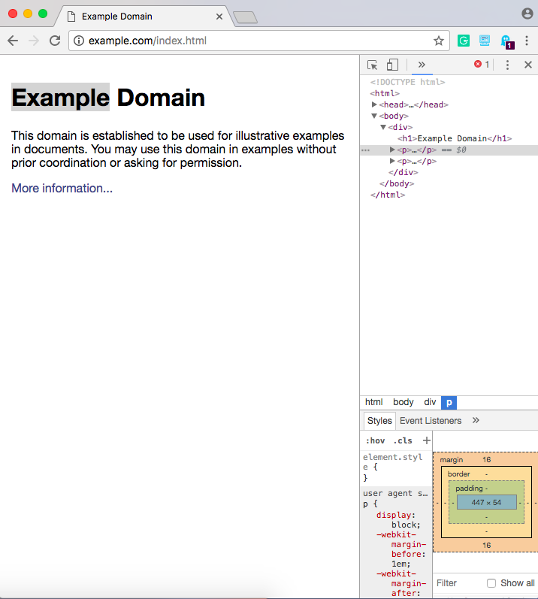

When the inspector first opens, it will likely be on the right side and be rather thin, depending on how large your browser window is.

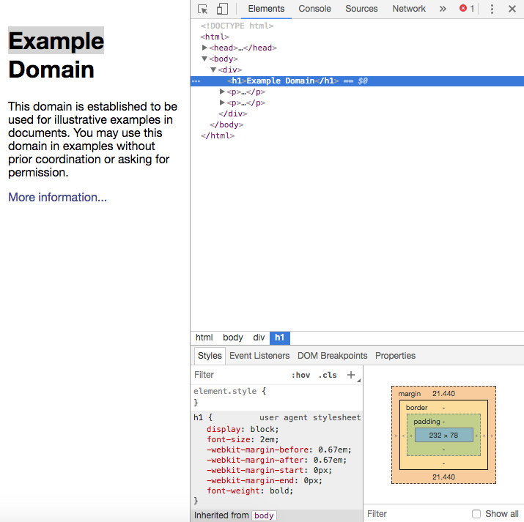

You can make the inspector window bigger by dragging the border to the left.

# Moving the Inspectordock-inspector-elsewhere.png

Personally, I like the inspector to be at the bottom of the page. To change where the inspector is located, or even pop it out into its own window, click on the three dots, circled in the picture. The menu will open, and you can choose where you want the inspector to dock, as shown in this picture.

# Pieces of the Inspector

There are four main pieces of the inspector. Refer to the picture to the left.

1. Outlined by the green rectangle is where you can find the source code - the HTML!
2. Outlined by the red circle is where you can find the styles - the CSS rules!
3. Outlined with the purple star is where you can see the margin, padding, and borders of the element.
4. The blue arrow points to the actual page

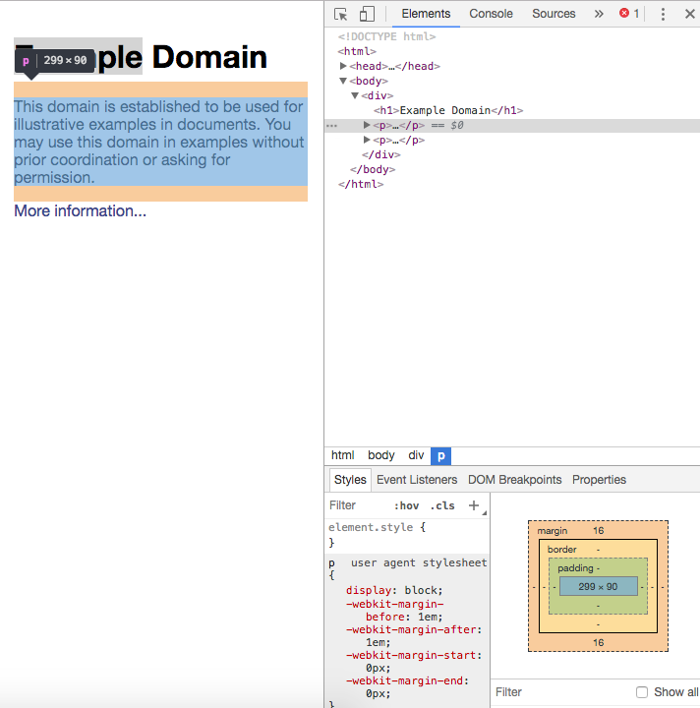

In Chrome, when you hover over an element in the HTML code, such as the “p” tag, the corresponding element on the page will be highlighted. A tooltip will appear, labelling what kind of tag it is and its dimensions.

# 

# Changing Styles with the Inspector

One of the best features of the inspector is the ability to change the CSS styles, or even add more styles. The changes are reflected immediately -- no need to even refresh the page!

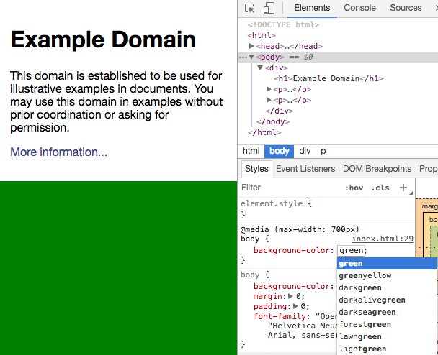

Here, the background color for the body has been changed from white to green. Usually, you can double click on the attribute value to change it. Alternatively, you can click on the attribute’s name and hit tab. In Chrome, possible values that you can use for the attribute will show up in a drop down menu for you to choose from!

# Adding Styles with the Inspector

In this example, a border has been added to the “p” tag. Notice that the style has been added in the “element.style” rule. Sometimes you can add new styles directly to the CSS rule. Again, Chrome will give you possible attributes you can add when you start typing, as well as suggesting values for the attribute.

# Visualizing Padding, Margin, and Borders with the Inspector

Using the model of the element that shows the content, padding, border, and margin, you can hover over each part to see where it is on the page. In the gif below, you can see that as the cursor hovers over each part of the box model, the corresponding part on the page is highlighted in the same color.



# Changing Padding, Margin, and Borders with the Inspector

Of course, in addition to just visualizing the padding and margin values, you can also change them! In the picture below, the left and right margins do not have values set, so they are represented by a dash. The padding values have all been added; they originally were not set. To change the value, click on the number or the dash to enter a different value.

# 

# 